Poster Presentation Guidelines

The goal for your scientific poster is to have an organized and attractively displayed presentation of your research findings. Posters should be self-explanatory and readable within five minutes. When constructing your poster, consider the following guidelines.

Suggested Elements

1. Title
At the top of your poster, include a title that is both short and very descriptive of your project. As a rule, the title should be easily readable at a distance of about 4 to 5 feet away.

2. Name and Affiliation
Directly under the title, include your name, your faculty sponsor's name, and your University's name.

3. The Body of the Poster

A. Abstract
The abstract is a brief synopsis of the entire work described in the poster. Most abstracts are one or two paragraphs in length. The abstract should be understandable without reading the entire poster, and the reader should be able to decide if she or he would like to read the entire poster based on what they read in the abstract. The abstract should contain the following elements: purpose of the study; a brief statement about what you did; a concise statement of the major findings; and the major conclusions. Do not include details of the methods.

B. Introduction
The purpose of the introduction is to present the question being explored by your research and to place it in the context of current knowledge about the topic. It often works well to start with the general context and work your way down to the specifics, ending with a precise statement of the question or hypothesis being addressed by your study. The introduction should convince the reader of the significance of your study. This is a challenging requirement. Be brief, but include the important points to make sure the reader sees the relevance of your work.

C. Methods
In this section you should describe all procedures that you performed. Describe your methods in sufficient detail to allow a reader who works in your field to understand what you did to collect your data. Illustrations are appropriate for complex experimental design.

D. Results (if applicable)
The purpose of this section is to summarize the data. Report the results of any statistical test here. Present all of your results, whether positive or negative. A table or figure may substitute for a written summary as long as each table or figure has a legend that explains the graphic clearly.

E. Discussion
In this section you should interpret the meaning of your results with respect to the original question. You should interpret your results without repeating them. The discussion must include your conclusions about the answers to the questions that motivated your research that you described in your introduction. If appropriate, mention any alternative explanations for your results and mention possible explanations for unexpected results.

F. Literature Cited
This section is optional in the poster, unless citations are used in the text. Include only those papers cited in the text. Do not cite a paper unless you have read it. Cite all of your references and list them in the literature cited section using a format from a journal within your discipline.

4. Graphics, Tables, Photos and Others
Illustrations, tables, figures, photographs and diagrams should have unique identification numbers and legends. In the text use the numbers to refer to specific graphics or pictures. In your legends, include a full explanation and where appropriate, include color keys, scale, etc.
You may use technology in your display, but keep in mind you do not have access to a power source.

5. Picking up your poster board
Poster boards are available to pickup in McGowan South
- 1st floor: Chemistry office
- 4th floor: Office of the CSH Dean

6. Samples of Past Showcase Posters

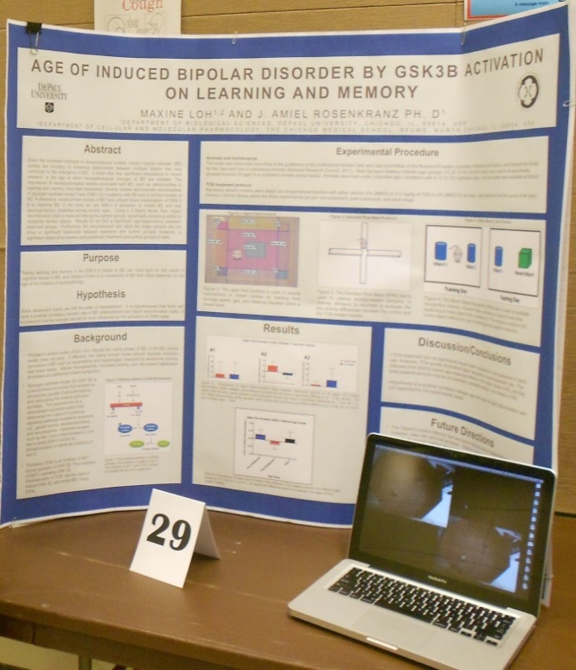
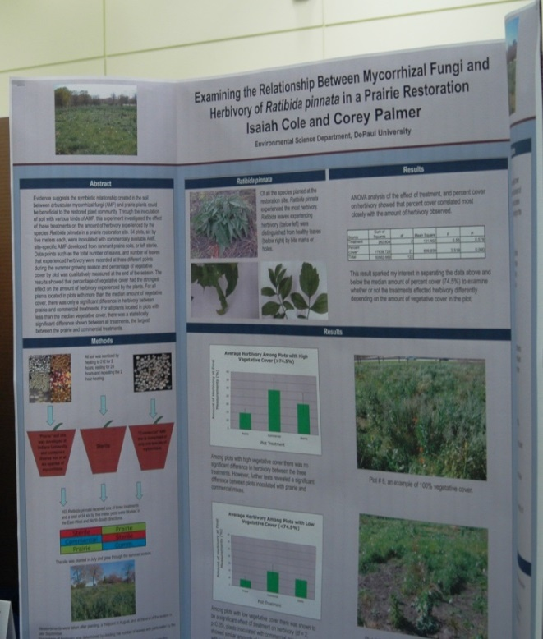

7. How to Print Your Poster
Do NOT wait until the last minute to print your poster. Printing early gives you time to practice your presentation and make any changes or corrections needed. The labs get busy around Showcase time, and you do not want to wait in line!

There are two large scale printing labs on the Lincoln Park Campus.

*McGowan South Third Floor [see faculty advisor to gain access to lab]
*Richardson Library, First floor

The boards are 48 inches by 36 inches. Plan to adhere the poster with tape, binder clips or push pins (some materials will be available at registration table). How to print your poster on the McGowan South 3rd Floor printer.

Additional information on location and set up will be emailed the week of the event.

If you have questions about the STEM Research Showcase, you can:
- Contact your Faculty Advisor
- Reach out to Mary Ann Quinn mquinn22@depaul.edu
- Find your departmental representative on the Showcase page: Undergraduate STEM Research Showcase | STEM Center | Centers & Institutes | About | College of Science and Health | DePaul University, Chicago

